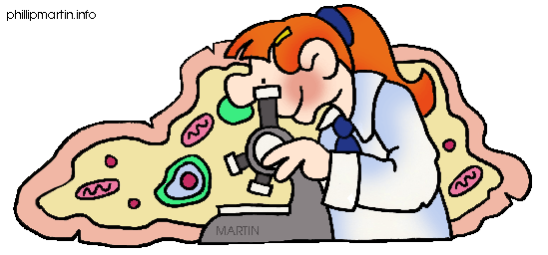
Mrs. Jorgensen Room 101 -2007/2008
Mrs. Palmer – Room 124
email: stacey.palmer@wrps11.ca
Google Classroom: z9b0wj7
e-teachers: www.wetaskiwincomp.ca
Remind 101: text @bio20palm to (780)666-7352

COURSE CONTENT

Unit A: Energy and Matter Exchange in the Biosphere
You will learn that the constant flow of energy and cycling of matter in the biosphere leads to a balanced or steady state (equilibrium). This balance is achieved through various biogeochemical cycles and the processes of photosynthesis and cellular respiration.
Chapters 1 & 2

Unit B: Ecosystems and Population Change
Ecosystems: You will become familiar with a range of ecosystems by studying their distinctive biotic and abiotic characteristics.
Chapter 3

Population Change: Students are introduced to the concept of populations as a basic component of ecosystem structure and complete the unit by examining population change through the process of natural selection.
Chapter 4

Unit C: Photosynthesis and Cellular Respiration
The life processes of photosynthesis and cellular respiration allow for the transfer of energy and matter. You will learn how energy from sunlight is eventually transferred to glucose during photosynthesis and how carbohydrates are converted to ATP during cellular respiration.
Chapter 5

Unit D: Human Systems (2 exams)
Maintenance of metabolic equilibrium in organisms involves a number of physical and biochemical processes. The human organism is used as a model to examine how energy and matter are exchanged with the environment through the processes of gas exchange, digestion, excretion, circulation and the function of the motor system. A defence system contributes to equilibrium by eliminating pathogenic organisms.
Digestion, Respiration & Muscles (Exam 1)
Chapters 6, 7 & 10

Circulation, Immunity and Excretion (Exam 2)
Chapters 8 & 9

TIMELINE

Unit D
Part 1 16 days Feb 4 - 28
Part 2 17 days March 4 – April 4

Unit A 13 days April 5 - 26

Unit C 10 days April 29 – May 10

Unit B 21 days May 13 – June 12
Field Study TBD (Coal Lake)

Review 4 days June 13 - 18

**All dates are subject to change**

COURSE EVALUATION

Assignments/Lab Reports 10%
Quizzes 20%
Unit Exams 40%
Final Exam 30%

Assignments: Assignments will be based on course work.

Lab Reports: The labs that you conduct will require either partial or full lab write-ups to be submitted for marks. If you have an unexcused absence on the day of a lab you will be given a mark of “0”.

Quizzes: There will be numerous quizzes throughout the semester. Quizzes will take a variety of formats and will be composed of multiple choice, fill-in-the-blank, matching and short answer questions.

*The majority of labs, assignments and quizzes will be weighted equally, as determined by percentages. Teacher discretion may determine that some evaluations, such as the Field Study, have heavier weightings.

Unit Exams: There will be 5 exams in the course. Each exam will be comprised of multiple choice, numerical response and written response questions. The weighting on each exam will be determined by the Alberta Program of Studies.

Final Exam: There will be a cumulative final exam scheduled during exam week. The exam will consist of multiple choice, numerical response and written response questions. The final exam will account for 30% of the final mark.
COURSE EXPECTATIONS

- Be Respectful – The classroom is an environment where everyone should feel safe, included and welcome. Please respect yourself, your classmates, your teacher and the classroom.

- Be Prepared – Bring all required materials with you to class and be ready to participate – take notes, ask questions and do practice problems. Active participation will help you to be successful in this course.

- Attendance - Regular attendance is an important aspect of success in a high school program. There is a direct correlation between your attendance and your mark! If you are absent it is your responsibility to catch up on any missed work and make sure assignments are handed in.

- Lates – I expect everyone to be in class and ready to begin when the bell rings – that is why we have a warning bell! When you are late it disrupts my teaching and it disrupts the learning of your classmates.

- Extra Help – I am available at lunch and after school to answer questions and help with course work – you just need to ask. Don’t let little problems become big problems.

LINKS

Academic Expectations
https://wetaskiwincomp.ca/students/academic-expectations

Inquiry into Biology (McGraw-Hill Textbook) Website
http://learningcentre.nelson.com/student/9780070960527/9780070960527.htm

Nelson Biology Website

http://www.school.nelson.com/ABbio20-30

user name: nelsonbio_student
password:nelsonbio_onlinelearning

Exam Bank

www.exambank.com

user name: wrps.wc
password: marbled

